CURRICULUM VITAE

SAKET RANJAN
C. V. RAMAN COLLAGE OF ENGINEERING
Electronics and telecommunication
Bidya nagar,mahura(BBSR)
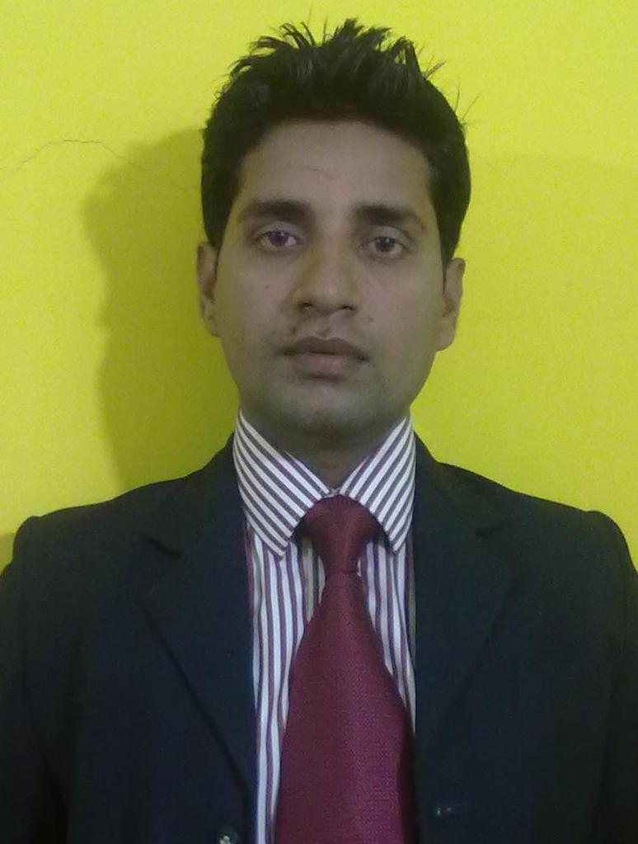

Email:- saket786ranjan@gmail.com
Mob.No:- +91 965815981
Career Objective: -
To make a promising career in the field of Teaching in an organization where my hard work and dedication will take me to the pinnacle of success while contributing to the organization.

Educational Profile: -

Qualification | Board/University | Institution | Year of Passing | Percentage/  CGPA
B. Tech. (E&TC) | BPUT(Odisha) | CVRCE, BBSR | 2012 | 6.5
10 +2 Sc. | BSEB(BIHAR) | R.K.D College  (PATNA) | 2006 | 48
10th | CBSE | S.T.Severin’s  High school | 2004 | 48.6

Projects Carried out in Graduate Level:-
- Workshop on CTIL-networking(01/04/2009-20/04/2009)
- Wifi-wimax

Personal skill:-
- Highly goal oriented
- Zeal to learn new things
- Confident at every situation
- Adjusting nature
Hobbies :
- Playing Chess
- Browsing the internet
- Listing music

Permanent Address:-
S/O- : Late shree ram naresh sharma
village.- : Mahangupur
PO/DIST- : Chiraura/Patna
STATE : Bihar
PIN :801109

Date of Birth : 25 Nov, 1988
Sex : male
Marital status : Unmarried
Nationality : Indian
Religion : Hindu
Language known : English and Hindi
Declaration:-
I hereby declare that the above written particulars are true to the best of my knowledge and belief. Given an opportunity to work in your esteemed organization, I shall put all my effort to live up to your expectations.

Date: 06/09/2011
Place: Bhubaneswar Signature:-Saket Ranjan

